CSA-0717

Lab Experiments 16-20

1. Simulating X, Y, Z Company Network Design and simulate using Packet Tracer.

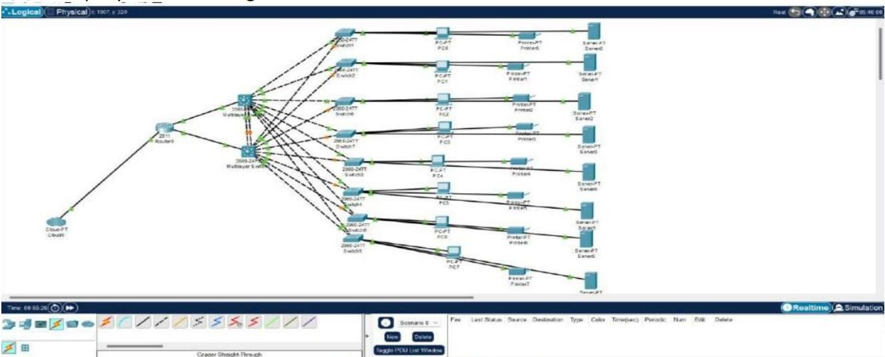

1. Configuration of DHCP (dynamic host configuration protocol) in packet Tracer.

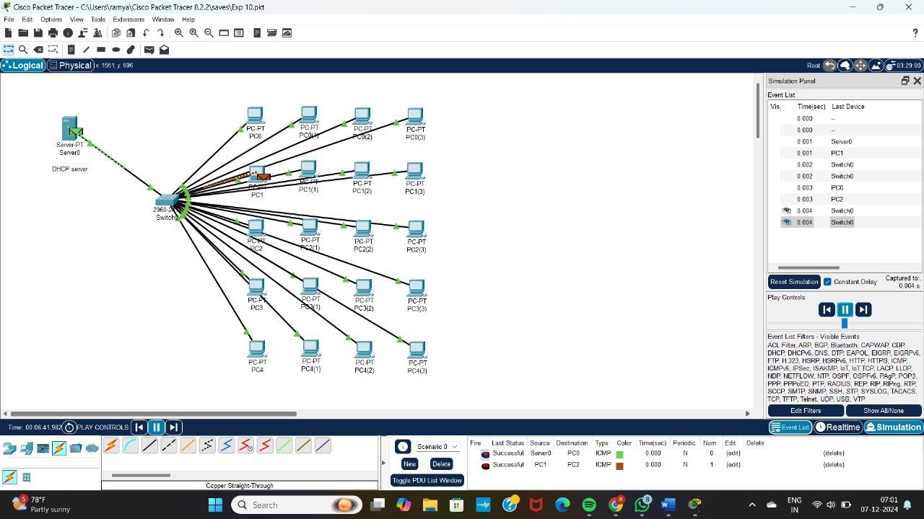

1. Configuration of firewall in packet tracer.

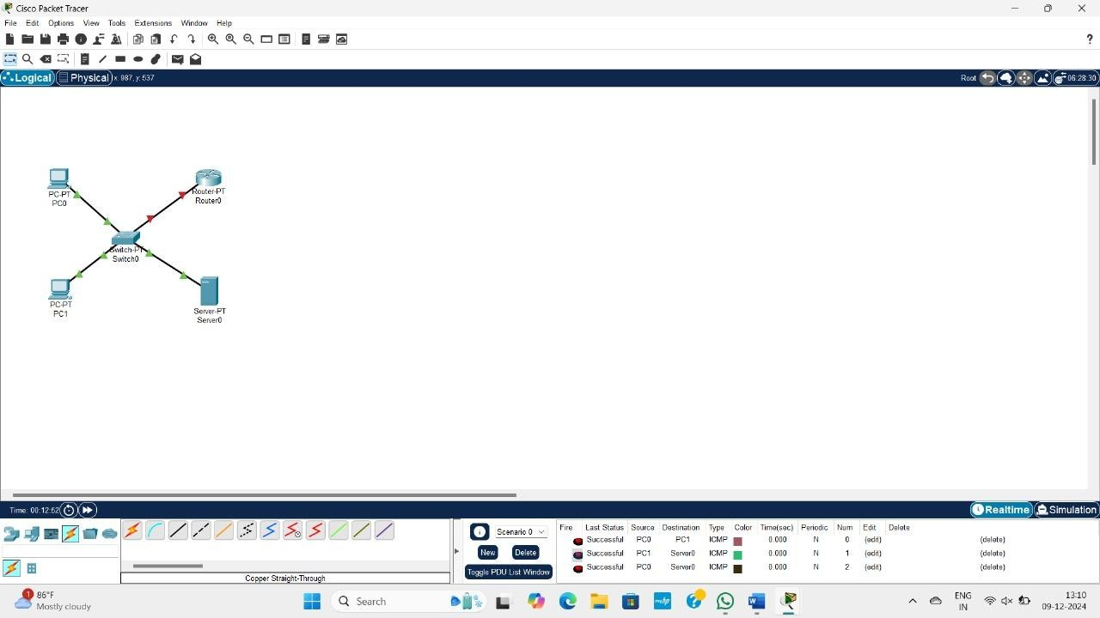

1. Make a Computer Lab to transfer a message from one node to another to design and simulate using Cisco Packet Tracer.

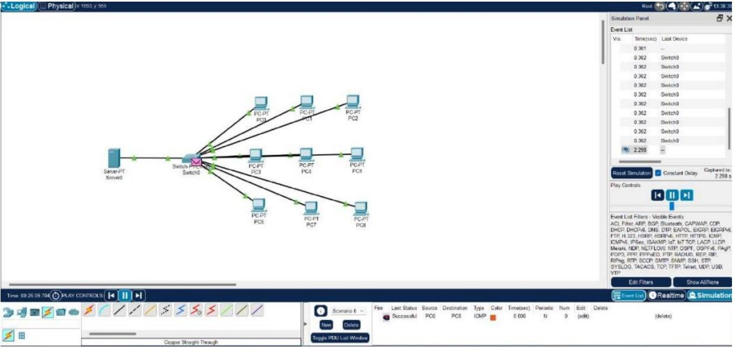

1. Simulate a Multimedia Network in Cisco Packet Tracer.

